# Comp 3350: Computer Organization & Assembly Language

# HW # 9: Theme: Advanced Procedures, Stack Parameters, Locals and BCD

*(All main questions carry equal weight. Credit awarded to only those answers for which work has been shown.)*

1. Write a procedure named *Geometric Progression* that fills an array of eight (8) numbers with the Geometric series. The procedure receives three arguments: the first is the offset of an array, the second is the first term and the third is the ratio. The first argument is passed by value and the others by reference. In the main program, you should set the parameters and print the series. Please run your program with several different first term and ratios.

Please embed your code into your homework solution along with a screen shot of the run of the program.

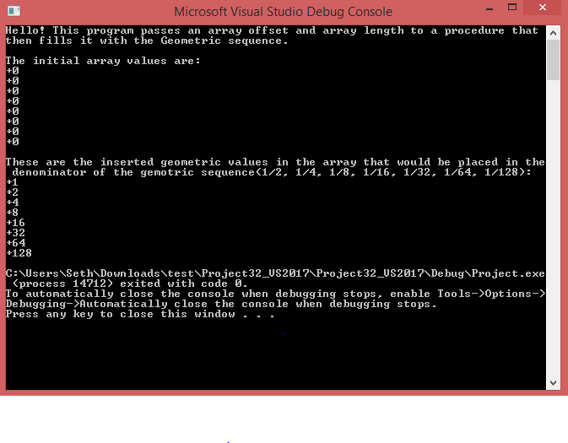

1. Draft a program that subtracts one BCD number from another (10-digits each). The first BCD number is stored in an array named *myAuburnID*, and the second in an array named *myAurbunIdRev*. The first number is your actual Auburn ID (with a prefix single zero digit and the remaining digits as the 9-digits of your *Auburn ID*); the second is the value of *MyAuburnId* written backwards. Your program should do the following:
2. Use shifts/rotates using *myAuburnID* to fill the array *myAuburnIdRev*
3. Display contents of the memory locations in question
4. Subtract *myAuburnIDRev from myAurbunId* using BCD arithmetic
5. Store the sum in a variable named *Result*, and
6. Display contents of memory post execution.

Please embed your code into your homework solution along with a screen shot post execution.

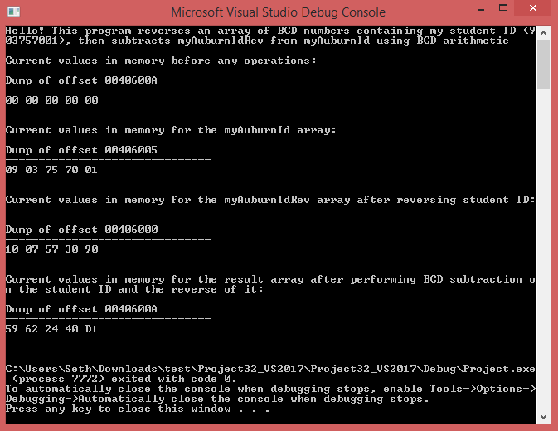

1. Consider an isosceles triangle A with base 8 and height 14. Consider another triangle B formed using vertices which are the center of the sides of triangle A. Consider another triangle C whose vertices are similarly formed from B. Repeat this process ad infinitum. Express the sum of the areas of all such triangles using a series and its closed form sum. Compute the areas *(a)* by using only the first two terms of the series and *(b)* by using the closed form of the series sum. Write a program to find the sums and use shifts to compute. What is the difference in the two computed sums?

Please embed your code into your homework solution along with a screen shot post execution.

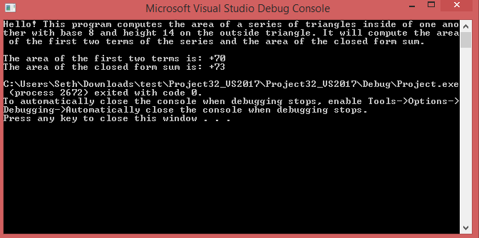

Answer: The difference in the two computed sums is that the first sum is more accurate, because the math is hardcoded, while the second is not. The second sum should not be 73 by using the math formulas we are using here. This is the difference.